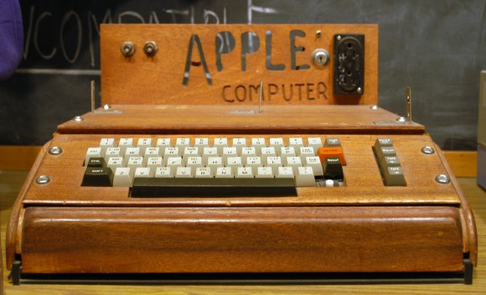

**“A Little Bit Better”**



Steve Wozniak

**(Co-founder of Apple & Inventor , August 11,1950 - )**

What do you really want to do? Please think about it. Do not need talent.